# WRDS Factor Definitions

Jensen, Kelly, and Pedersen (2023) groups 153 stock-level characteristics into 13 economic themes. They also specify the constituents of these themes. The 13 economic themes and their constituents are:

1. Accruals

1. Debt Issuance

1. Investment

1. Low leverage

1. Low risk

1. Momentum

1. Profit Growth

1. Profitability

1. Quality

1. Seasonality

1. Short-term reversal

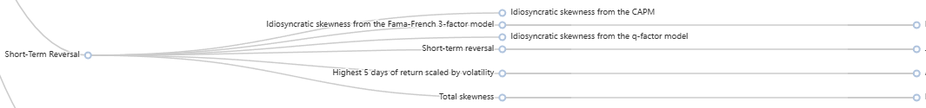

1. Size

1. Value

